-- ============================================================
-- Session 1 — Introduction to Databases
-- Practice database: InstaClone
-- Run this in MySQL Workbench (open a SQL tab, paste, click the lightning bolt)
-- ============================================================
-- ---------- Task 1:Install MySQL Workbench on your computer, connect to the local MySQL server, and take a screenshot of the default databases shown in the Schemas panel.----------

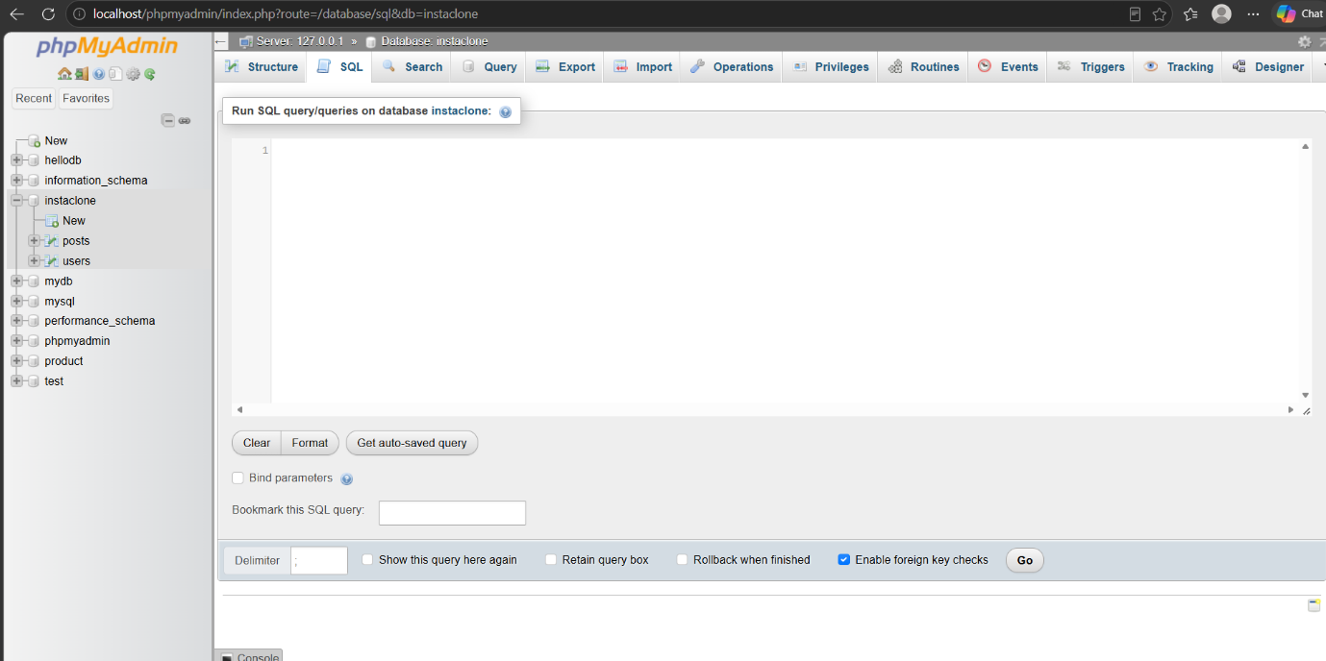

-- ---------- Task 2: create the database and the Users table ----------

CREATE DATABASE IF NOT EXISTS InstaClone;
USE InstaClone;

CREATE TABLE Users (
user_id INT PRIMARY KEY,
username VARCHAR(50) NOT NULL UNIQUE,
email VARCHAR(100) NOT NULL,
followers_count INT DEFAULT 0
);

-- ---------- Task 3: insert 3 sample users ----------

INSERT INTO Users (user_id, username, email, followers_count) VALUES
(1, 'priya.clicks', 'priya.clicks@example.com', 12450),
(2, 'rohan_travels', 'rohan.travels@example.com', 8730),
(3, 'the.chai.diary', 'chaidiary@example.com', 45200);

SELECT * FROM Users;

-- ---------- Task 4: Posts table with a foreign key to Users ----------

CREATE TABLE Posts (
post_id INT PRIMARY KEY,
user_id INT,
caption VARCHAR(255),
post_date DATE,
CONSTRAINT fk_posts_user
FOREIGN KEY (user_id) REFERENCES Users(user_id)
);

-- Optional: a few posts so the relationship is visible in the demo
INSERT INTO Posts (post_id, user_id, caption, post_date) VALUES
(101, 1, 'Golden hour on the terrace', '2026-09-10'),
(102, 2, 'Day 3 in Leh — no filter needed', '2026-09-12'),
(103, 3, 'Cutting chai + monsoon = perfect', '2026-09-15'),
(104, 1, 'New lens, first test shot', '2026-09-17');

-- ---------- Checking the relationship works ----------

-- Join: every post with the username that made it
SELECT p.post_id, u.username, p.caption, p.post_date
FROM Posts p
JOIN Users u ON p.user_id = u.user_id
ORDER BY p.post_date;

-- Proof the foreign key is enforced — this should FAIL, because
-- there is no user with user_id = 99. Uncomment to test.
-- INSERT INTO Posts VALUES (105, 99, 'Ghost post', '2026-09-18');

-- Confirm the foreign key exists in the schema
SHOW CREATE TABLE Posts;

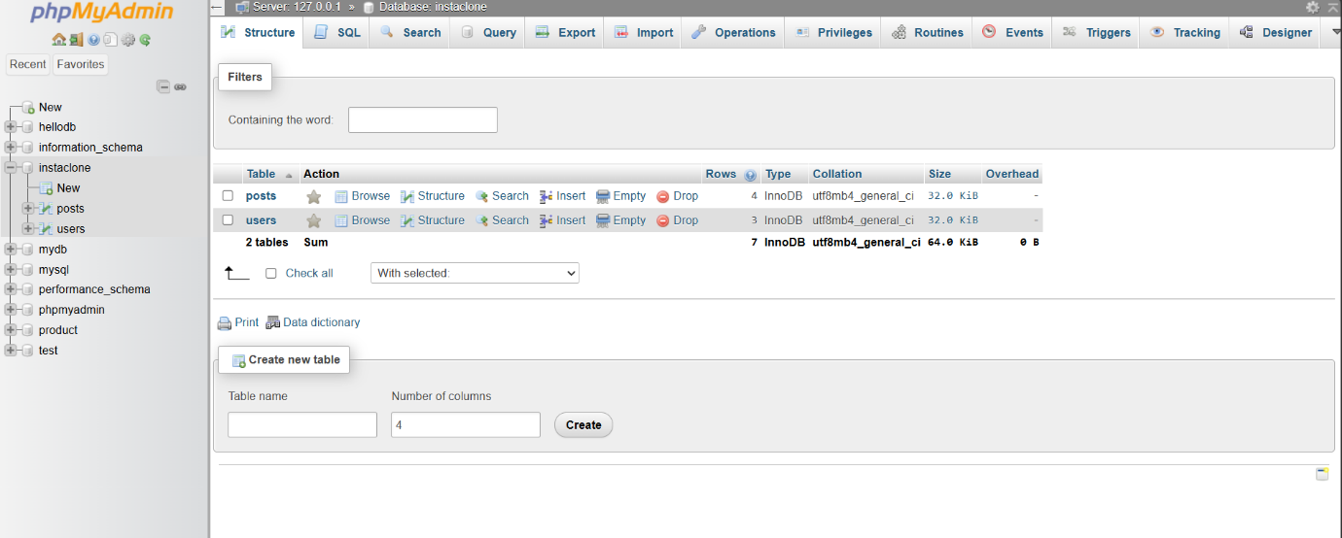
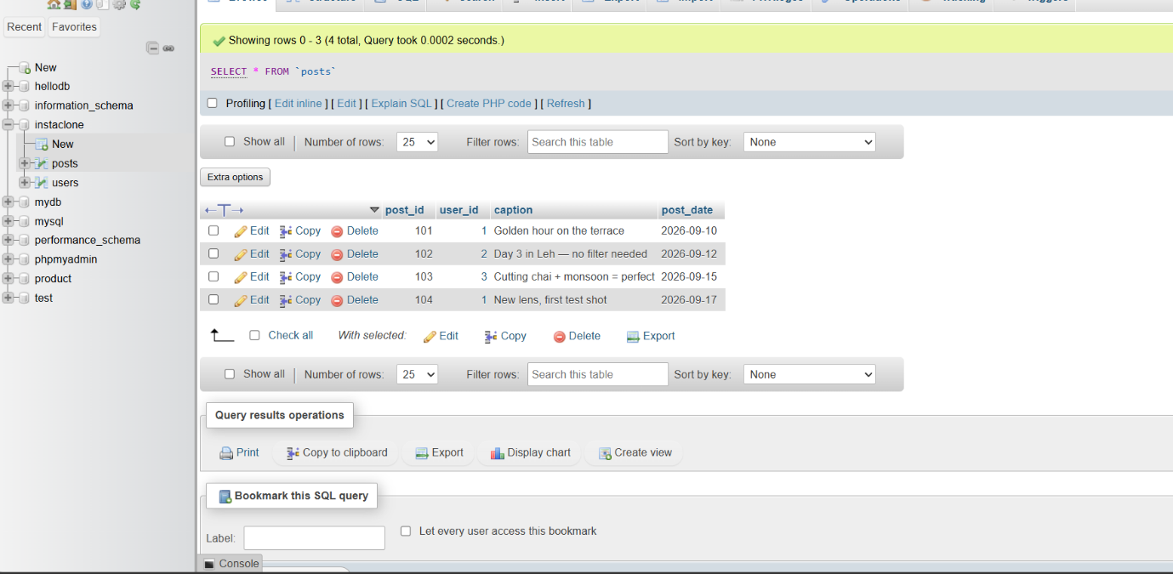
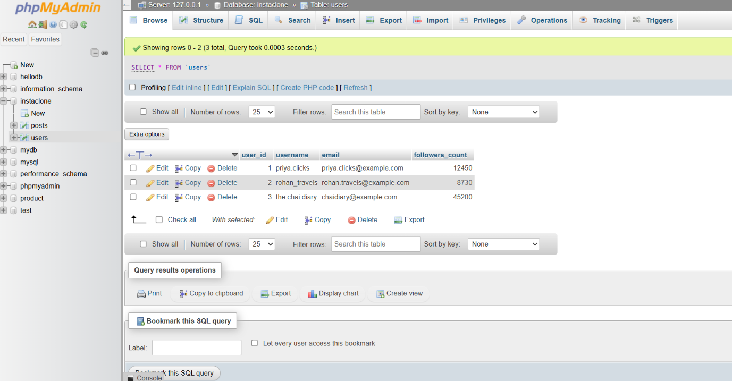

Task 5 — comparison:
MySQL — The most common database behind web applications. It powers a huge share of PHP/WordPress sites and is the default in LAMP/XAMPP stacks. Free, fast for read-heavy workloads, and easy to host anywhere. Typical use: blogs, e-commerce sites, CMS platforms, small-to-medium web apps.
PostgreSQL — Also open source, but stricter about standards and much richer in features: JSON columns, window functions, custom data types, geospatial support via PostGIS. Preferred where data integrity and complex queries matter. Typical use: fintech, analytics platforms, SaaS products, government and research systems.
Oracle — A commercial enterprise database, licensed and expensive, but built for very large mission-critical workloads with strong security, clustering and 24/7 support. Usually run by dedicated DBA teams. Typical use: banking, insurance, telecom, ERP systems like Oracle EBS and SAP.
SQLite — Not a server at all; the whole database is a single file embedded inside the application, with zero setup or configuration. Tiny and serverless, so it can't handle many concurrent writers. Typical use: Android and iOS apps, desktop software, browsers, IoT devices, and local caching.

